Arsenic accumulation in Chlamydomonas reinhardtii cells grown in As-contaminated media
MAVRAKIS E.¹, SAKELLARAKI E.², GAULIER M.³, RIAUDEL A.³, PERGANTIS S¹ and LYDAKIS SIMANTIRIS N.^{2*}
¹Department of Chemistry, University of Crete, Voutes Campus, 71003 Heraklion, Crete, Greece,
²Department of Environmental and Natural Resources Engineering, Technological Education Institute of Crete, 3 Romanou str., 73133, Chania, Crete, Greece,
³Department of Chemistry, IUT Rennes, France
*corresponding author:
e-mail: lydakis@chania.teicrete.gr

Abstract To gain a better insight into the metallome of a biological organism it is important to quantitatively determine metals and/or metalloids in individual cells, the basic biological units of all living organisms. This is needed because biological populations are heterogeneous, so knowledge of the metal distribution in a cell population can complement the average metal concentration. Single-Cell (SC) analysis by means of single-particle inductively coupled plasma mass spectrometry (SP ICP-MS) is in the position to reveal the metal distribution in a cell population. In this work, Chlamydomonas reinhadtii, a model unicellular photosynthetic alga, was grown in media polluted with four different arsenic salts, at several non-lethal concentration levels. Growth curves were constructed and the effects of As pollution on the growth rate of the cells were examined. The As content of individual Chlamydomonas reinhardtii cells were quantitated through the use of conventional ICP-MS and SC ICP-MS. Comparisons are being made between cell suspensions incubated in different arsenic salts.

Keywords: Chlamydomonas reinhardtii, arsenic, heavy metal pollution, single-cell-ICP-MS
- Introduction
Chlamydomonas reinhardtii is a unicellular, freshwater photosynthetic alga which is used as model organism for multidisciplinary research for several years, due to many advantages it provides for studies in plant sciences or in environmental sciences and toxicology, either at macroscopic or at the molecular mechanistic level. It’s genome is completely known (Merchant et al., 2007), and it is used extensively for molecular research. C. reinhardtii, and in general photosynthetic algae are in the basis of the nutrition chain, and, besides nutrition, they play very important role in several processes in the environment. These organisms are vulnerable to pollution, which in most of the cases is of anthropogenic origin. Pollution of water systems with heavy metals or toxic metalloids result the adsorption on cell walls as well as the insertion of these pollutants into the cells, with all the consequences to the higher forms of life, and finally to humans. Thus, the potential of using these organisms as indicators for early detection of pollution in the environment, and consequently, the prevention of its dispersion, is very important (Perales-Vela et al., 2006, Torres et al., 2008). To materialize this potential is important to know the details of the behavior of these cells when exposed to the pollutant(s). Using different approaches (i.e. biochemical/physiological measurements and spectroscopy) we can have a multiparametric view of the response of the cells to pollutants. In this study, we examine the behavior of Chlamydomonas reinhardtii, exposed to a range (100 – 400 μΜ) of four arsenic compounds, sodium arsenite (AsIII), sodium arsenate (As V), methylarsonic acid (MMA), and dimethylarsinic acid (DMA), which correspond to the most common forms of arsenic in the environment. Growth curves of this organism were constructed for all the tested conditions and the tolerance limits for the different levels of pollution were determined. Preliminary results on the arsenic accumulation in the cells of C. reinhardtii as determined by conventional ICP-MS and SC-ICP-MS are also presented.
- Material and methods
Chlamydomonas reinhardtii cells were cultivated under continuous illumination at 25º C in TAP media supplied by acetic acid as organic carbon source. Appropriate amounts of stock solutions of arsenic compounds were added to the media, for the decided concentrations to be reached. For the construction of growth curves, a small-volume experiment was designed, where cylindrical cuvettes were used for growing cells in 5 mL of TAP, with or without (control) arsenic in triplicates. The culture development was monitored spectophotometrically every twelve hours, by recording the optical density at 750 nm. For massive cell production, 2 L flasks were used with 1.5 L of TAP medium. Cells were harvested at the end of the log phase, washed by a washing buffer and kept in a high density sucrose solution at -80 º C until use.
The arsenic content of the cells was determined by ICP-MS. For the preparation of diluted cell samples for SC-ICP-MS, cell counting was done by a microscope on a Fuchs hemocytometer.

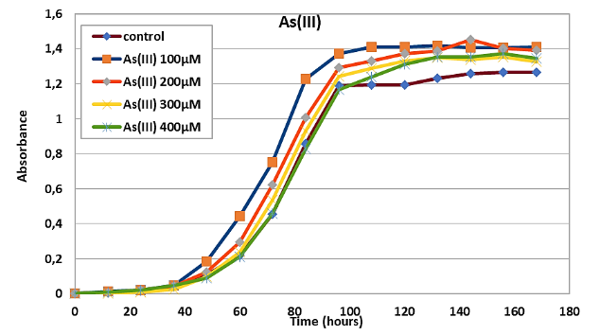
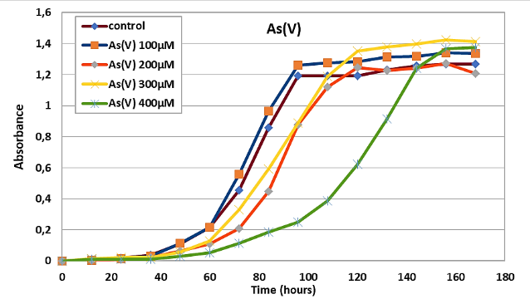
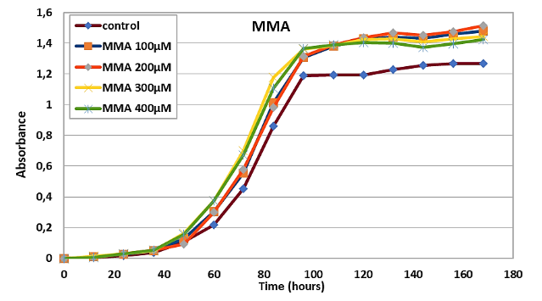
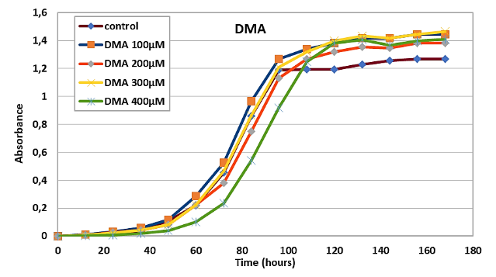

Figure 1. Growth curves of C. reinhardtii exposed to arsenic compounds.

- Results and Discussion

Figure 1 presents the growth curves of Chlamydomonas reinhardtii, grown in control, unpolluted media and in media polluted with the indicated levels (μM) of arsenic compounds.
In general, the levels of the arsenic compounds in the nutrient media were not lethal for the cells. Exposure to higher levels of As(V), especially to 400 μM, resulted in slower growth compared to control. This result is in agreement with studies from other research group (Walliwalagedara et al. 2012). All other conditions did not affect either the growth rate or the final cell population at the steady-state phase of the cultures.
Table 1 presents data from SC-ICP-MS (As III and As V in the cells or dissolved) and from conventional ICP-MS (total metal content), by which the recoveries of the SC-ICP-MS experiments were calculated. These results show that the SC-ICP-MS method is reliable for the determination of the metal content in individual cells.

Table 1. As (III) and (V) content in the cells and in total solution
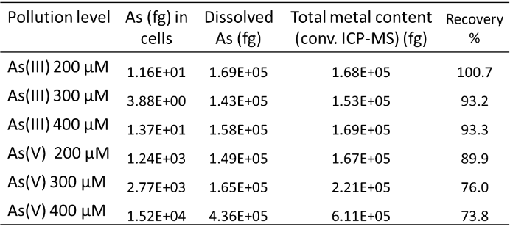

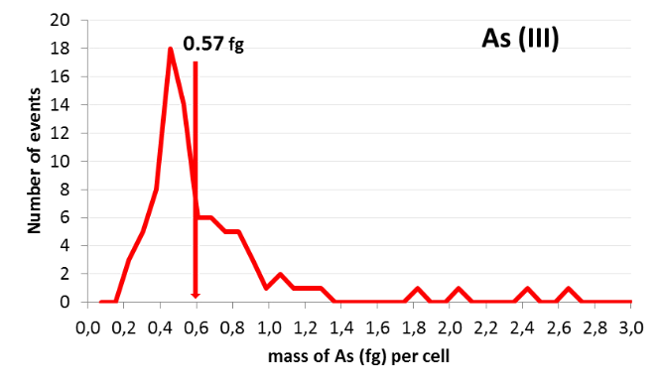
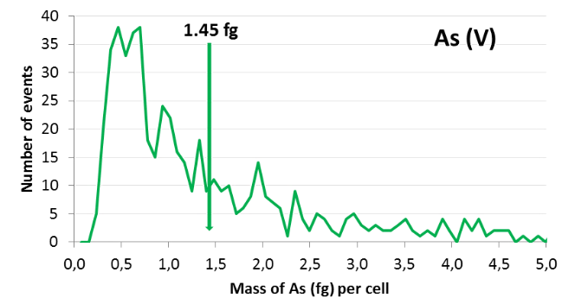
Figure 2. Number of events recorded by SC-ICP-MS from samples containing cells of Chlamydomonas reinhardtii exposed to 400 μM sodium arsenite (upper graph) and to 400 μM sodium arsenate (lower graph). The arrow indicates the mean mass value of As (III) and As (V) per cell, as calculated from all the recorded events.

The mean masses (in fg) of As (III) and As (V), calculated per cell from SC-ICP-MS data, are shown with an arrow in Figure 2. These experiments are with cells exposed to 400 μΜ of arsenic compounds. It is clear that exposure of the cells to sodium arsenate (As V) results in much higher accumulation of arsenic in the cells, compared to the accumulation of As III after exposure to sodium arsenite. Additionally, the number of events recorded in the detector of the instrument vs. the mass of the arsenic ions shown in Figure 2 for the two oxidation states of the element. The higher number of events for As (V) indicates the higher possibility of As in the form of sodium arsenate to accumulate in the cells of Chlamydomonas reinhardtii. It is possible that the higher accumulation ability of As(V) compounds to enter the cells cause the lag in the growth shown in Figure 1 for higher As(V) levels in the nutrient media. Work is in progress to expand our analyses to the cells exposed to the other two arsenic compounds (MMA and DMA) considered in this study.

References

Merchant S. et al., (2007), The Chlamydomonas Genome Reveals the Evolution of Key Animal and Plant Functions, Science, 318, 245-250.
Perales-Vela, H.V., Pena-Castro, J.M., Cansares- Villanueva, R.O. (2006), Heavy Metal Detoxification in Eukaryotic Microalgae, Chemosphere, 64, 1- 10.
Walliwalagedara C., van Keulen H., Willard B., Wei, R. (2012), Differential Proteome Analysis of Chlamydomonas reinhardtii Response to Arsenic Exposure, American Journal of Plant Sciences, 3, 764-772.

